**Planning and Clarifying the Task**

# Electronics and Software modules

1. **Bale detection** – Image processing. Coordinates of the bale shall be communicated from the control station to bale lifter wireless.
2. **Communication** - Communication between control station to bale collector and between bale collectors shall be via wireless LAN. Because internet access is limited in remote areas.
3. **Obstacle detection** – Ultrasonic sensor shall be used for obstacle detection. Once the threshold distance is met, vehicle shall stop and change the direction to reach the destination accordingly.

# Mechanical modules

1. **Mobility** – This autonomous vehicle shall have continuous tracks like in military tanks. So, when there is rain fall and loose soil, this design will make the vehicle suitable for all terrain.
2. Vehicle shall have -30° motorized conveyor to take the bale on the vehicle. Horizontal non-motorized roller conveyor for bale

# List of Actuators

1. motor to drive rear wheels × 1 (RPM 00)
2. motor to drive the conveyor belt × 1
3. hydraulic jack to lift the storage area for unloading × 1

# List of Sensors

1. Camera – For bale detection × 1
2. Ultrasonic sensor – For obstacle detection × 4

# Other Electronics

1. Battery – Capacity TBD
2. Controller – ESP32

# Environment Scenarios

1. There can be obstacles.
2. Due to rain fall, muddy soil.
3. Vehicle collision

# Vehicle Anatomy

Our design shall have 4 wheels. Two rear wheels shall be powered by motors and two front wheels will be driven by a belt connected to rear wheels as shown in the figure 1. This bale collector shall have bale storage platform provided with non-motorized roller conveyor for easy loading and unloading.

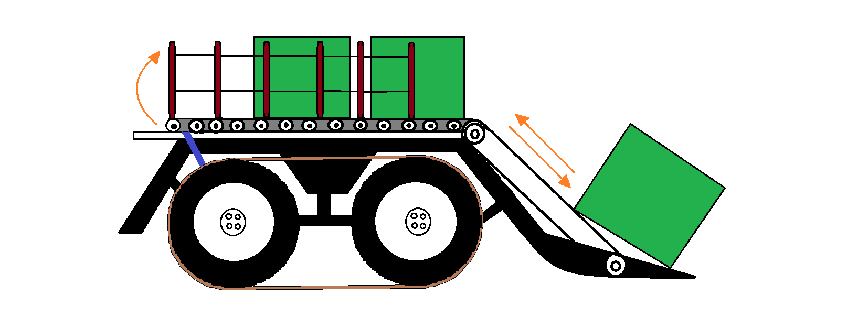

Figure 1: Design of the bale collector

## Size of Storage platform

There are 3 designs with different platform sizes for different size bales.

1. Small with platform size 3’ x 2’ for small sized bales

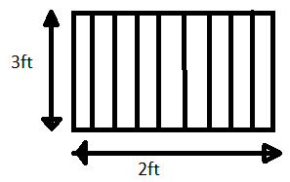

Figure 2: Platform for small bales

1. Medium with platform size 3’ x 4’ for medium sized bales.

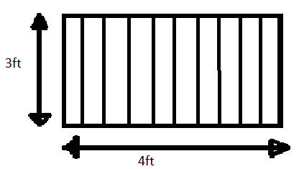

Figure 3: Platform for medium bales

1. Large - with platform size 3’ x 8’ for large sized bales.

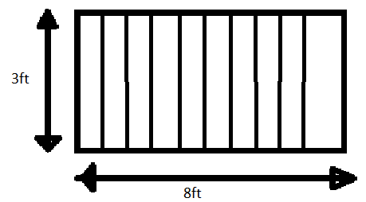

Figure 4: Platform for large bales

Height of all the bales shall be 4 feet.